**Azure VM HyperV - Reinstall Cloudera**

Daya Rudhramoorthi

Adjunct Faculty

Northeastern University

Accidently, if you delete Cloudera from you Azure VM’s Hyper-V, follow below details to reinstall.

In this example, my machine already had Cloudera and hence I am installing another called Cloudera 2.

1. Click New -> Virtual Machine

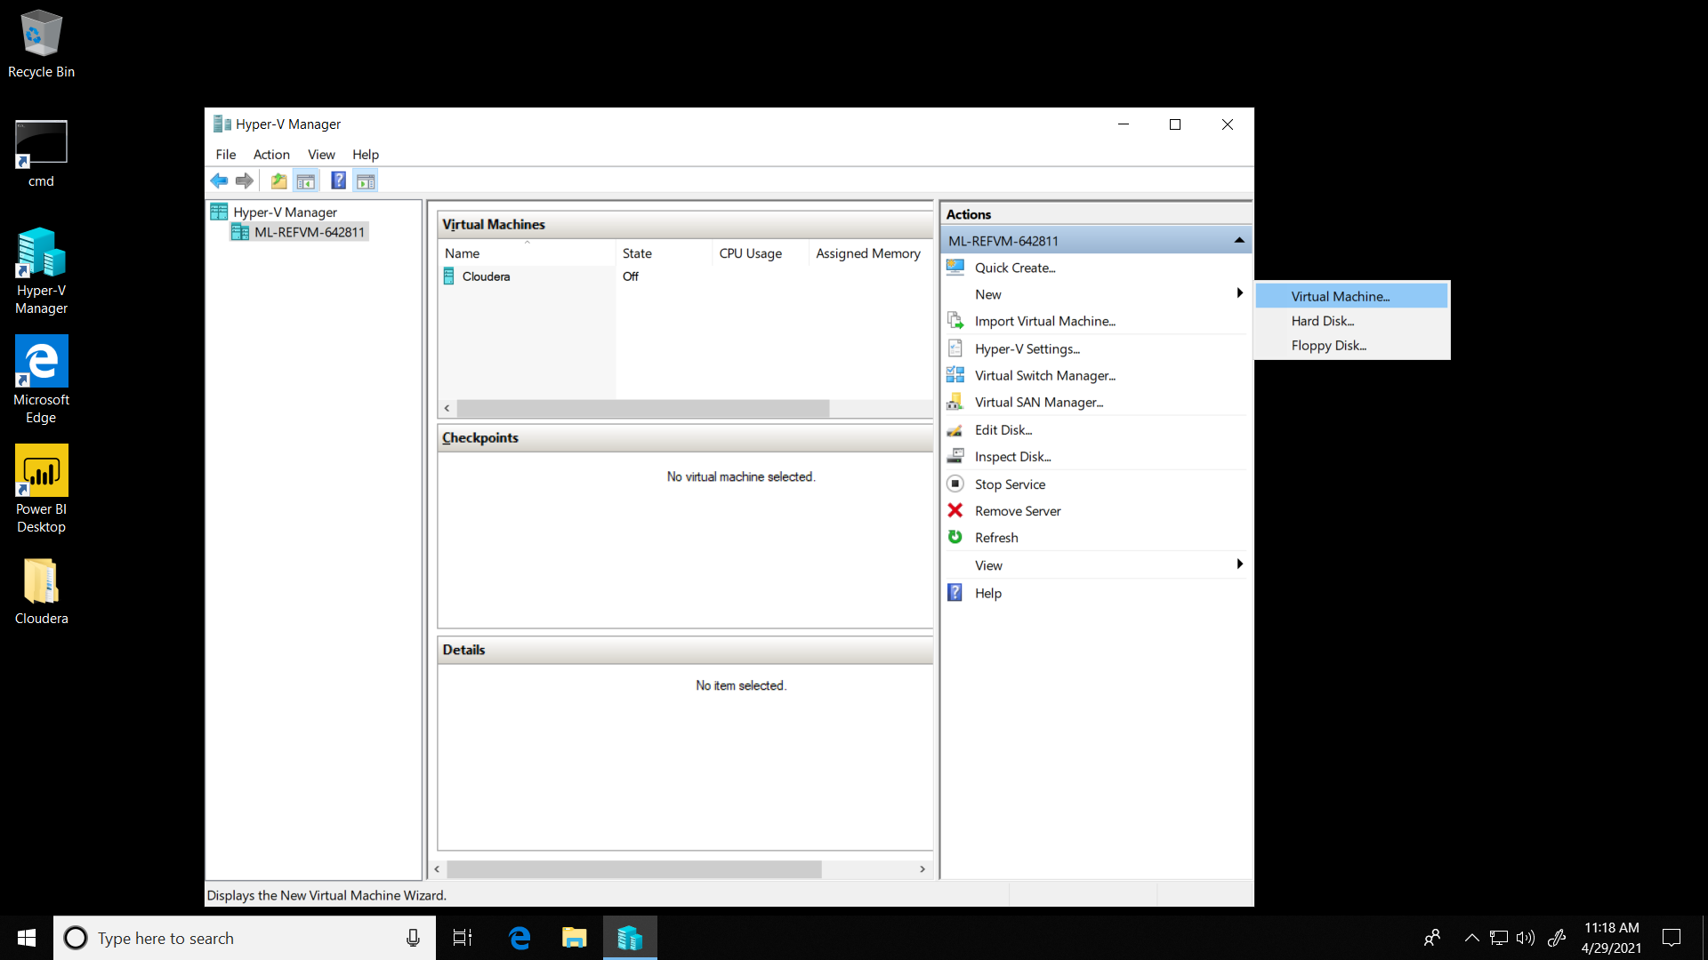

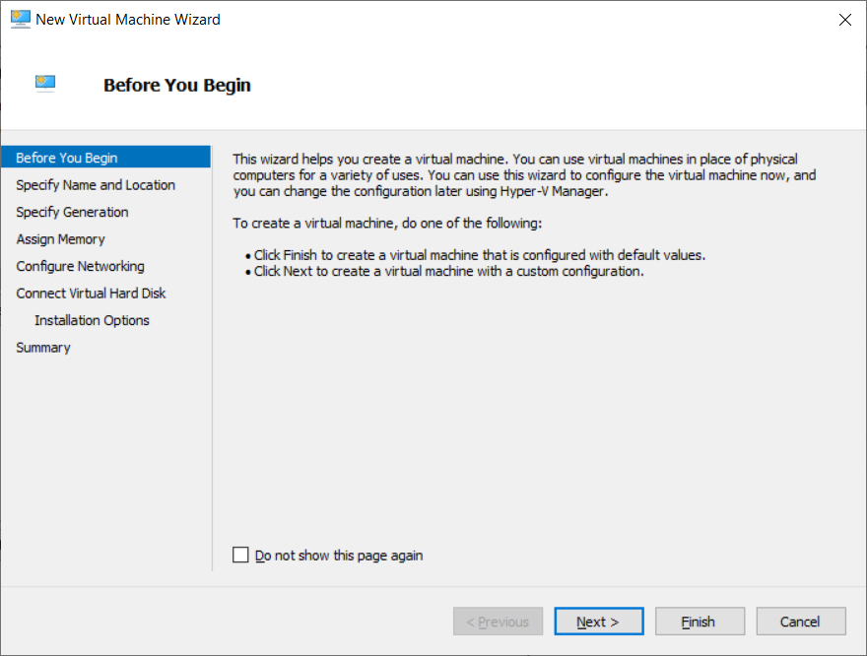

1. Enter New Name, “Cloudera”

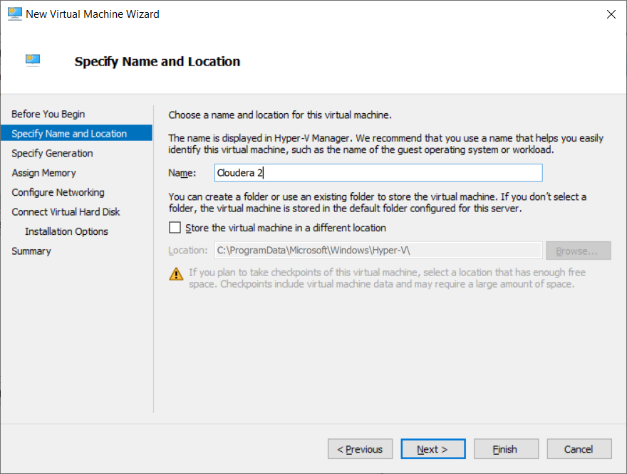

1. Select Generation 1

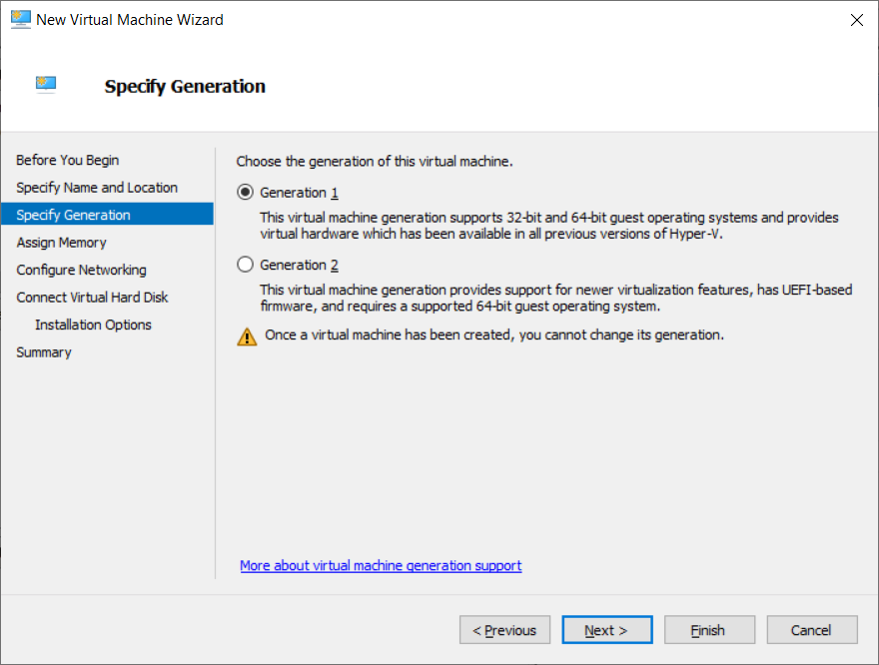

1. Enter 16384 as memory.

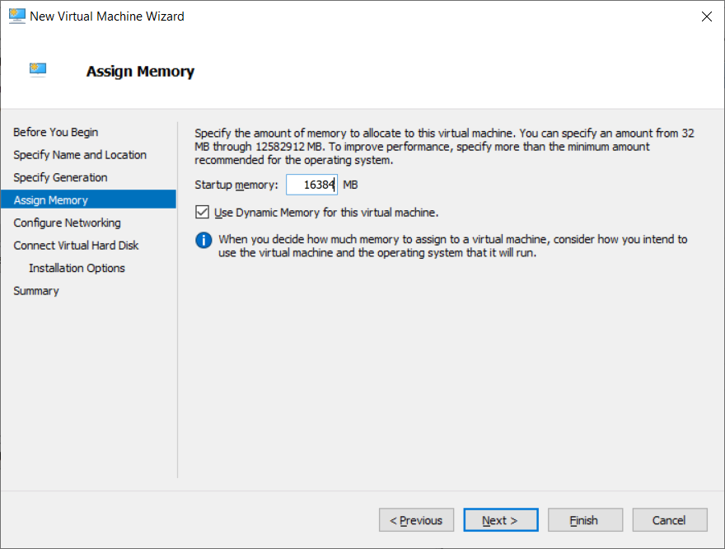

1. Update Configure Networking to “Default Switch”.

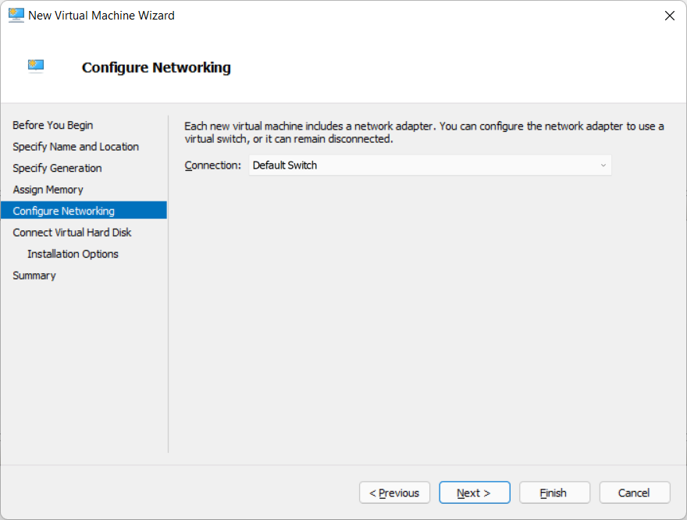

1. Select “Use an existing virtual hard disk” and copy and paste “C:\Software\HyperV\cloudera-quickstart-vm-5.13.0-0-hyperV.vhd” in Location (If you downloaded HyperV zip file, then point to the folder where you have unzipped).

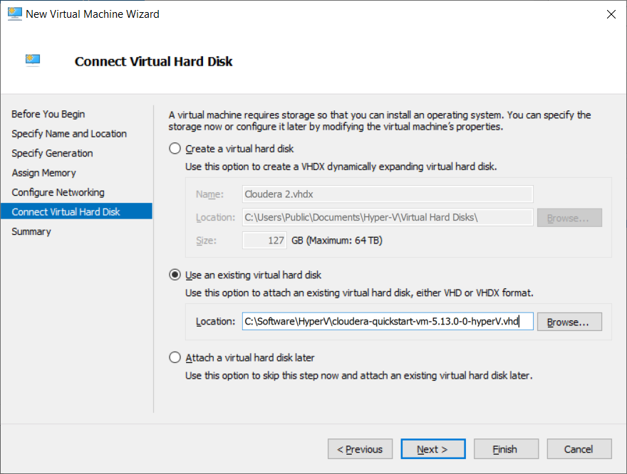

1. Click “Finish”

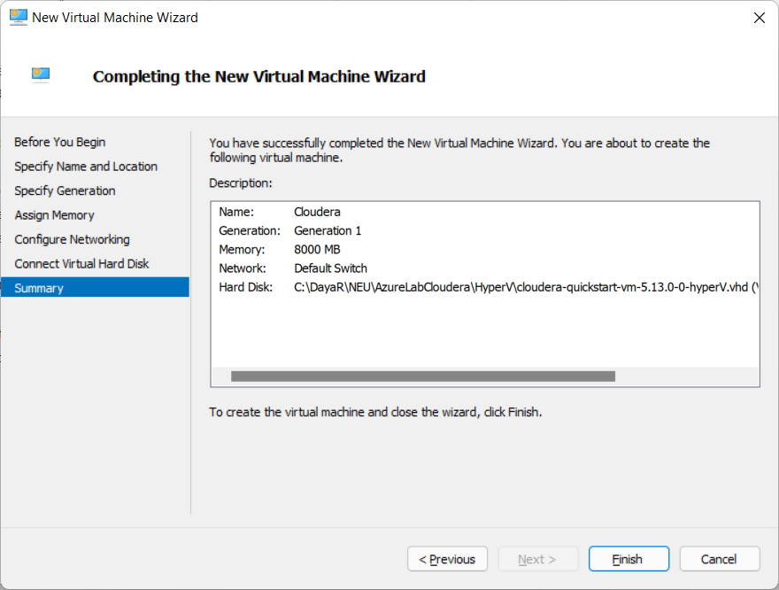

1. Now you should see newly added Virtual Machine “Cloudera 2”.

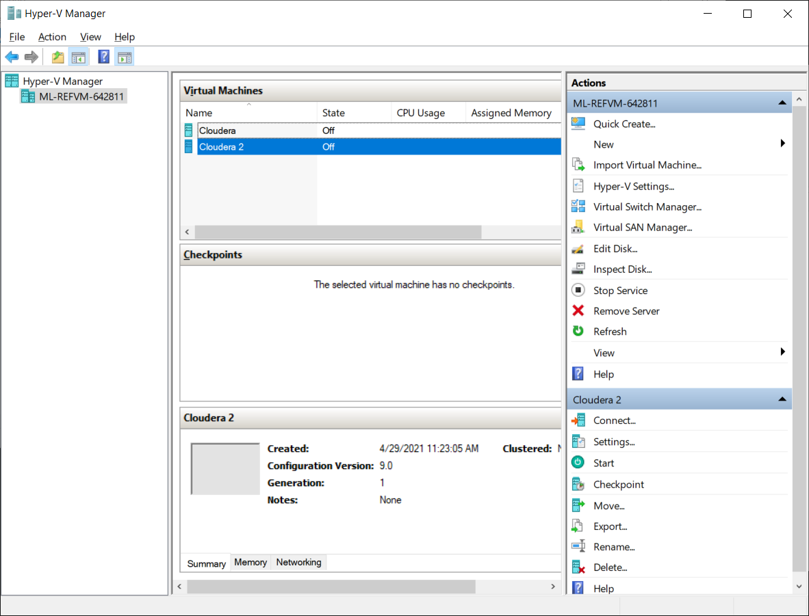

1. By default, “New Cloudera” instance will have only one processor. This needs to be updated to 4 otherwise, it will take very long time to start Cloudera. To update processors, select newly added Cloudera, right click to get the properties values and select “Settings”

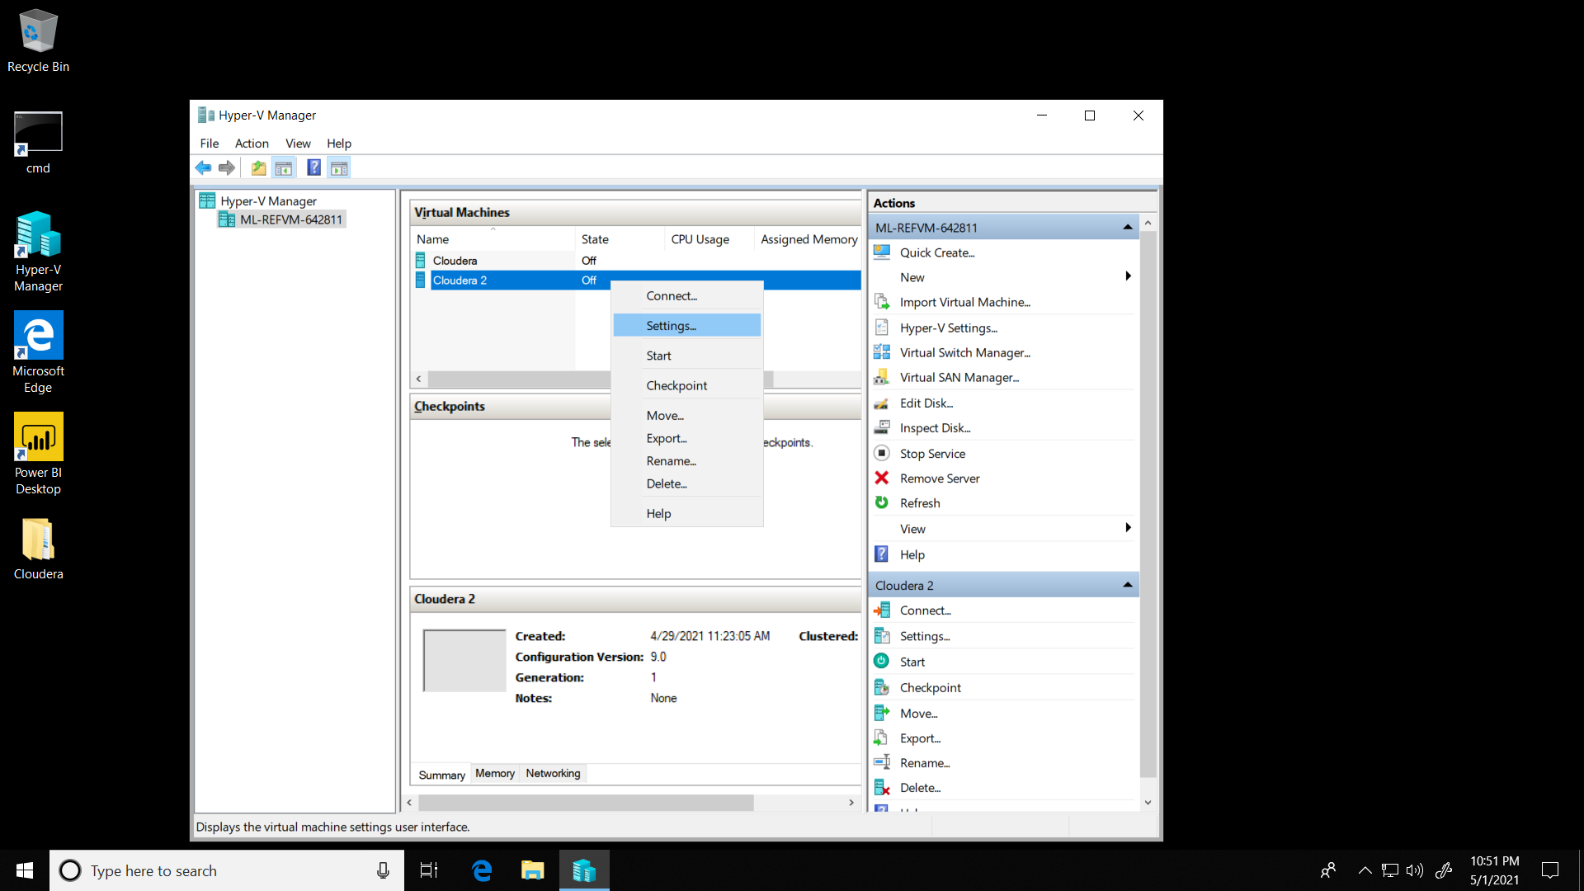

1. Select “Processor”, Update “Number of virtual processors” to 4 as shown below and click “Ok”.

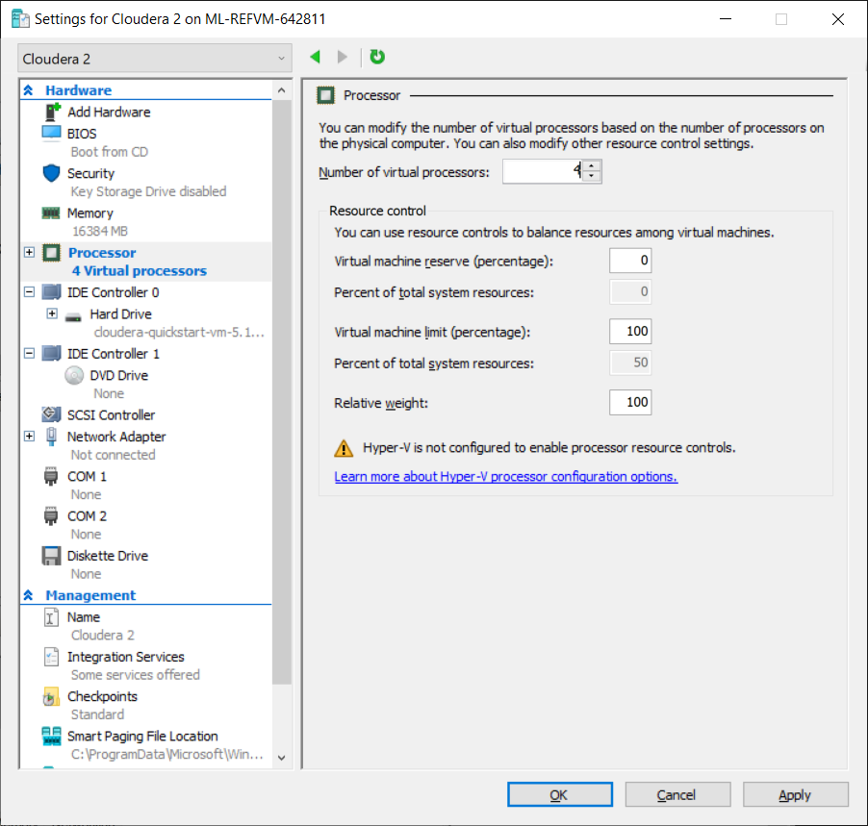

1. Now, new instance of ready and click “Start” to start CentOS/Cloudera VM.
2. After connecting to Cloudera and clicking “Cloudera Manager” hangs for more than 30 mins, follow the instructions in document “Cloudera Manager Hanging Issue – Fixes” that’s located in Module 1 Lab 0 Assignment.